Simulated LoRa Sensor Network as support for Route planning in solid waste collection∗

Montañez Gomez, Miguel Angel  
 computer science & Industrial faculty   
 Universidad Nacional de Colombia, Bogotá  
 mmontanezg@unal.edu.co

Niño Vasquez, Luis Fernando  
 computer science & Industrial faculty   
 Universidad Nacional de Colombia, Bogotá  
 lfninov@unal.edu.co

ABSTRACT

Mass production and population growth has produced an increase in generation of municipal solid waste (MSW) in urban settlements as consequence efficient treatment of waste has become a challenge for cleaning entities, possibly because they continue performing collecting operations using fixed periodic routes that exhaustively go across neighbourhood streets in search of every dumpster, further in this operations recyclable material is not separated from disposable one at least in Bogota, causing a negative impact to the environment. This work aims to prototype a sensing system that generates routes based on actual fulfilment level reported by dumpsters, to accomplish so dumpsters were equipped with a level measurement device which uses a proximity sensor, information gets transmitted using an LPWAN (LoRa), collected data is used to determine which of the dumpster needs to be collected in the route planned for a date and which ones can be defer until next collection, according to fulfilments levels reported. Since an operation requires many collecting trucks, a K-means method is used to group dumpsters that are geographically close, collecting sequence was calculated using an open Web service, results are shown on Android mobile application, the mobile app consumes Google Maps routing service, this demonstrates technical viability for implementing this sorts of systems in real operation environments, a single district of Bogota was selected for demonstration purposes.

KEYWORDS

IoT, Waste Collection, wireless sensor networks, LoRaWAN, sensing system, CVRP, geographic information, mobile application**.**

Cite this Article:

MONTAÑEZ G, M,. NIÑO V. L. 2021. Sensing system prototype base on a simulated Wireless Sensor Network as support for Route planning solid waste collection: …*, 13 pages.* DOI.

1. Introduction

Globalization and industrialization of factories have significantly reduced the cost of products allowing us to access to all kind of goods ranging from clothes, electronic devices and house equipment among many more. This low cost offer has change society consume habits, increasing the amount of products that are sell, replaced and thrown-away in small periods, that besides non-biodegradable packaging used to protect products and fast growth population induced a massive amounts of MSW production, indeed in north America waste production has duplicate between 2006 and 2010. According to a World Bank Group’s report (Kaza et al, 2020) world generates 2.01 billion tons of MSW each year, at least 1/3 of that waste is not properly managed.

Non treated solid waste is endangering ecosystems, producing greenhouse gases, and contaminating ecosystems having a negative impact not only in human’s health and life style, but also the environment damaging animal habitat and ocean ecosystems, then it becomes a critical aspect to perform an efficient treatment of solid waste management.

An efficient treatment of MSW encompasses at least 3 aspects: reduction of waste generation, a structured recycling process and a proper disposition of non-reusable waste, waste classification and transportation is an important step in recycling process, commonly city governments are responsible for collection logistics.

(Campbell & Wilson, 2014) explain how collecting MSW has been treated with a deterministic approach using periodic routes for more than 40 years, this problem is known as periodic vehicle routing PVRP, under this approach collector trucks travel along fixed routes one or more days per week, repeating same routes every week. This approach was useful until few year ago but has shown to be inefficient to satisfy big cities necessities such as Bogota, as in some districts solid waste overflows container capacity and ends spilled on the ground. This produces aesthetic problems of city cleanness and bad smells that might it attracts s insects or rats that can transmit infections turning the situation into a public health problem.

Hence to drive this research we address a way to structure the logistic process of RSU collection according to the necessities of a single district of Bogotá, trying to achieve an efficient collection operation that reduces container saturation and overflow.

Primary contributions from this work are:

1. Assembling three different configurations for measure devices, using a long distance transmission technology.
2. Testing and comparing transmission range of Assembled devices.
3. A simulation of waste generation in the streets of a district in Bogota, then using simulated information to generate routes dynamically considering real-time traffic.
4. A mobile application that shows container fulfillment levels, containers locations and shows generated routes on a map.

The remainder of this paper is arranged as follows. In section 2 a brief review of related work, Section 3 presents the system architecture overview, then Section 4 describes system implementation including hardware integration, data collection and transmission, transmission range distance test, data simulation, route generation and mobile application demonstration. In section 5, we discuss results and system performance, finally conclusions and future work is suggested in section 6.

1. Related Work

Trying to stay sustainable and thinking on citizen well-being cities governments strive to find an efficient way to collect and manage MSW, to target this concern many studies have being proposed for instance (Babaee Tirkolaee, Abbasian, Soltani, & Ghaffarian, 2019) have proposed an efficient simulated annealing (SA)  applied to RSU collection in Sanandaj, Iran. Heuristics-algorithms using python scripts in ArcGIS where proposed by (Amal, Son, & Chabchoub, 2018) which was tested in Sax, Tunisia. In south America an example takes place in lima Peru where (Gilardino, Rojas, Mattos, Larrea-Gallegos, & Vázquez-Rowe, 2017) suggested a mathematical optimization model to reduce number of compactors trucks trying to reduce greenhouse emissions.

Other solving approaches include a two-phase memetic algorithm that uses clustering and sequencing for solving VRP with time-windows (Bustos Coral, Oliveira Santos, Toledo, & Fernando Niño, 2018). swarm optimization (Abdulkader, Gajpal, & Elmekkawy, 2015), genetic algorithms (Fujdiak, Masek, Mlynek, Misurec, & Olshannikova, 2016) or an hybrid of both (Kuo & Zulvia, 2017) these researches show important results the first reducing distances and collection times, and second they show a fast solution convergence which is important considering VRP is a NP-hard problem.

Routing of vehicles using Geographic information systems GIS and network analytics have also being studied (Chaudhary, Nidhi, & Rawal, 2019) and (Jwad & Hasson, 2018), used the ArcGIS network analytics tools, to define collection zones and streets paths, here fuel usage, distance, time and number of vehicles are quantified as variables in an efficiency equation to evaluate solution performance.

These researches offer solutions in terms of static routes, which underestimates the fact that waste generation is a non-deterministic phenomena, then using static routes might reduce distance, time or even the operation’s cost, but they are no estimating real city necessities. One of the difficulties to do that estimation is the lack of updated information in relation to solid waste generation, this problem was identified by (Medvedev, Fedchenkov, Zaslavsky, Anagnostopoulos, & Khoruzhnikov, 2015) they highlighted the importance to provide elements of collection systems with certain degree of perception using IoT components like sensors, RFID or cameras to get real time information leading to an optimized collection based on the information reported by components. This vision completely change the way we understood MSW collection and open an IoT perspective that has being widely accepted and researched by scientist community.

In this boom of IoT solutions for waste generation sensing, low cost ultrasonic sensors HC-SR04 is commonly used to measure filling level, the main difference is data transmission technology e.g. GPRS is used by (Yusof, Zulkifli, Mohd Yusof, & Azman, 2018) to communicate dumpster levels as notifications direct to mobile terminals, this approach result insufficient as little data processing is done to allow significant decisions.

More complex and complete sensing system were proposed by (Pardini et al., 2020) in which the measured device integrates a load sensor HX711, temperature and humidity sensor DHT11, GPS module NEO6M, apart from the ultrasonic sensor, the circuit was assembled on an arduino board, data is transmitted using GPSR module SIM900 which operates in 2G cellular technology, processed information is delivered to citizens through a mobile application, calling for community interaction to receive feedback that can be applied to enhance collection planning.

Anyhow GPRS results to be quite expensive in terms of energy usage so (Karthikeyan, Rani, Sridevi, & Bhuvaneswari, 2018) implemented a wireless sensor network WSN using Zigbee as transmission technology, Zigbee uses a particular topology in which measurement devices communicates to coordinator nodes, this coordinators serialize information and transfer it to a gateway, in the research the gateway was built on the top of an Raspberry PI, an MQTT broker was used to manage the data between the network and the applications, this work is pretty useful as it reports transmission ranges and concludes that Zigbee shows 97% reliability in distances shorter than 80 meters, exceeding this distance signal got considerably attenuated and packages got lost.

A similar work was published (Chaudhari & Bhole, 2018) in this one the selected transmission technology was WiFi the coverage distances were very closed to the ones reported with the use of zigbee, between 100 and 120 meters, this works uses a mobile application to show locations of containers that exceed defined threshold on a map, so the user interface is much explicit and easier to understand. A very similar solution was published in (Kang, Kang, Ilankoon, & Chong, 2020) but it was oriented to deal with electronic waste exclusively.

Presented distance limitations can be handled using LPWAN (Low Power Wide Area Networks) that is a set of technologies capable of cover wide cities with few devices. A relevant research of LPWAN applied to waste management systems is presented by (Lozano, Caridad, De Paz, González, & Bajo, 2018) in this case information is transmitted using LoRa modulation they declare LoRa signal can deliver data in a range of 5 to 15 Km consuming around 0.5 µA. They were able to deploy a WSN for the rural Area of Salamanca it shows an important improvement reducing collection cost compared to the static collection approach.

An important aspect to consider in a WSN is energy efficiency as we expect to give the least possible maintenance to end nodes, constantly replacing batteries may become a problem for network maintainability, a comparison among three of the popular transmission technologies were compared in the context of agricultural monitoring, Zigbee, WiFi 2.4 GHz, and LoRaWAN. The results show that LoRaWAN have better yield when power consumption and transmission distances were the priority. (Sadowski & Spachos, 2020)

Apart from the right technology is critical to consider how end devices manage energy to have a longtime working network, thus node architecture presented by (Cerchecci et al., 2018) this one extends battery life on end device. They attached a low consumption timer and a trigger to the node, the idea behind this architecture is that after the main circuit gets the measure, sends the information and gets confirmation from the server it sends a signal to start timer and switches down the measurement circuit. The timer and will go counting until the next measurement cycle is required consuming 4μV, when the cycle completes it triggers again the measurement circuit avoiding it to be running the whole time misspending energy.

LPWAN have being applied to several fields, showing high performance and reliability to transfer data and fault tolerance, some interesting applications include: livestock remote surveillance base on a collar to monitor cows’ vital sings (Li, Liu, & Xiao, 2018). metering the average consumption of households in the electrical grid in cities (De Castro Tomé, Nardelli, & Alves, 2019). Remote sensing humidity of soils and control field irrigation in agriculture (Zhao, Lin, Han, Xu, & Hou, 2018). To reduce the cost of public street illumination by adjusting brightness, detecting abnormal consumption and determine when a streetlight needs maintenance (Bingol, Kuzlu, & Pipattanasompom, 2019). In an ad hoc network in a bicycle share system in Lyon-France, to share data where bicycles are equipped with a transmission module and bike stations are bridged to internet to send data collected by bicycles (Zguira, Rivano, & Meddeb, 2018)

Once IoT server receives data, to process the information in a way that routes could be efficiently computed becomes the challenge, it has a high complexity because finding paths in multiple routes is a combinatorial problem. In the case of waste collection, trucks have a limited load capacity, they should go along a set of locations picking up the waste material until their load capacity is completed, the material has certain weight or volume but this should never exceed the capacity the truck can carry, this is known as the capacitated vehicle routing problem CVRP (Faulin, Juan, Lera, & Grasman, 2011). In response (Medvedev et al., 2015) suggested a simple top-K query method, that executes a query on a relational data base and select the K containers reporting the highest fulfillment levels, container coordinates lat-lon are sent to a Google Services that deliver best routes having into account streets configuration.

If locations are updated constantly, routing can be carried out with a combinatorial General Variable Neighborhood search as presented in (Papalitsas, Karakostas, Andronikos, Sioutas, & Giannakis, 2018) with this method containers are organized by insertion according to their characteristics. They are placed near to containers that have similar latitude and longitude, similarity is measured using Euclidean distance, so container are organized in ascendant order this aims to cluster container that are spatially close, once all selected containers are inserted in the list, it is separated preserving order and considering truckload capacity. The algorithm was coded in Fortran and validated with the benchmark offered by Heidelberg University in TSPLIB (Heidelberg University, 1997)

1. System Overview and Architecture

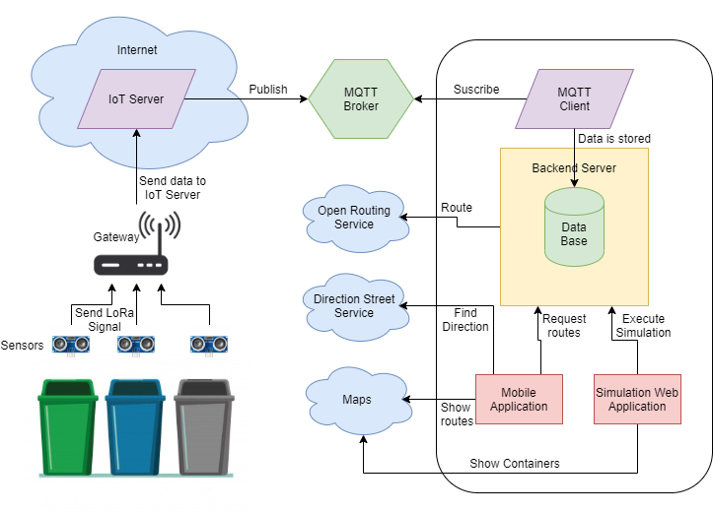

**Figure 1**: General Configuration and communication of system components

The proposed system is arranged as show in figure 1, the fulfillment level is sensed in within certain periods. Containers are indexed in a database with a unique identifier and geographical location (Lat, Lon) in such a way that as data is received, it is possible to know the approximate location of the container whose level is being reported. This data is transmitted using LoRaWAN protocol, LoRa Signal is decoded in the gateway and repeated to internet, where it gets routed to an IoT Server where data is managed, a server appliance publish this data to a topic in a MQTT broker.

Once the information is registered in the broker, it can be query via an MQTT client running in a Backend server that subscribes to the topic and retrieves data that is stored in a database so the applications can access it when required. Given the limited amount of measurement devices for the selected area a simulation was required to execute routing with significant data. Simulated data is used to plan daily operation, simply put; a priority is given to the streets base on the level reported by the containers located in that street using rules explained in section 6.

Having in to account the estimated volume of MSW to be collected in the zone and the number of trucks required to pick that volume, a clustering method is executed in order to group streets which are geographically close, so computing time in routing operations could be reduced. Routing was managed using an Open Web Service.

Calculated routes are displayed using an App Mobile, the App demands generated routes to the backend server, and then it shows the streets the trucks should go through and the locations of dumpsters that need to be served. A map provider was integrated so the information of routes can be easily interpreted; it also uses a direction service that indicates the way to truck, considering real-time traffic information to prevent the trucks to turn around or to be stuck in traffic jams.

4. Methods and Results

4.1. Hardware Integration

Measuring the level is possible using a weight sensor however there are some discussions as depending of the material density the container might report high weight without being full, or vice versa. For that reason, we decided to use a distance sensor HC-SR04. The operation principle behind this sensor is to emit an ultrasonic signal, the signal travels in the air until it collides to the closest obstacle then the signal is reflected and the sensors receives the signal back. Distance is estimated measuring the delay between the signal emission and it is acquire, as explained with formula 1.

$$Distance=\frac{\left(Speed X Delay\right)}{2} (1)$$

The sensor returns back the time, as we know that sounds propagates at 334 m/s in the air this is to say 0,0334 m/µs it is split by 2 as the signal spends time to go and return. Then, we can calculate distance.

For simplicity, hardware was assembled using development boards integrating analogical and digital pins, for conceptual reasons three configurations for measure units were explored and analyzed, all these can be described whit the block diagram in Figure 2.

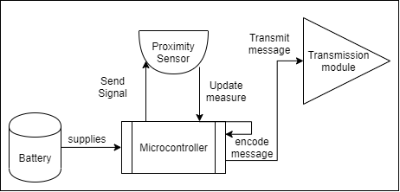

**Figure 2:** Block diagram Measure unit components

The first configuration was made on the top of an Arduino Mega Board with a LoRa Shield created by Dragino both devices where connected according to the pins mapping and digital pins 30 and 31 were used to connect proximity sensor as showed in Figure 3, table 1 states pin interfacing between HC-SR04 and Arduino.

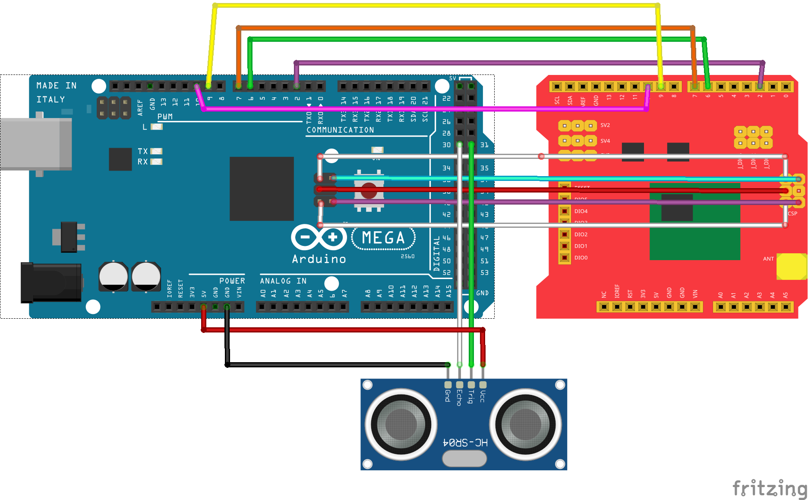

**Figure 3:** Connection diagram for Arduino and Dragino Shield

|  |  |
| --- | --- |
| **Arduino** | **HC-SR04** |
| 5 V | 5 V |
| GND | GND |
| D30 | Echo |
| D31 | Trigger |

Table 1: Arduino to HC-SR04 pin mapping

The next circuit was set using a board that integrates LoRa transmission module, which simplifies the connection of component as the only component that needs to be added to the board was the proximity sensor, as show in figure 4, table 2 states pin interfacing between HC-SR04 and TTGO.

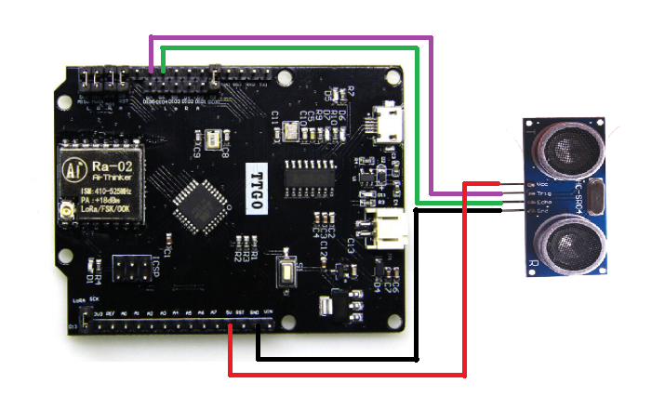

**Figure 4:** Connection diagram for TTGO and HC-SR04

|  |  |
| --- | --- |
| **TTGO** | **HC-SR04** |
| 5 V | 5 V |
| GND | GND |
| D6 | Echo |
| D7 | Trigger |

**Table 2:** TTGO to HC-SR04 pin mapping

The third circuit has a small difference compared to the previous ones as this one integrated a GPS module (U-blox neo 6-m), in such a way that geographical location can be obtained precisely this may help to be more accurate when planning the route. However this have significant impact in energy efficiency. Apart from that as the container locations remains almost constant, updating the location each time a measure is taken is not recommended the circuit was assembled as shown in figure 5.

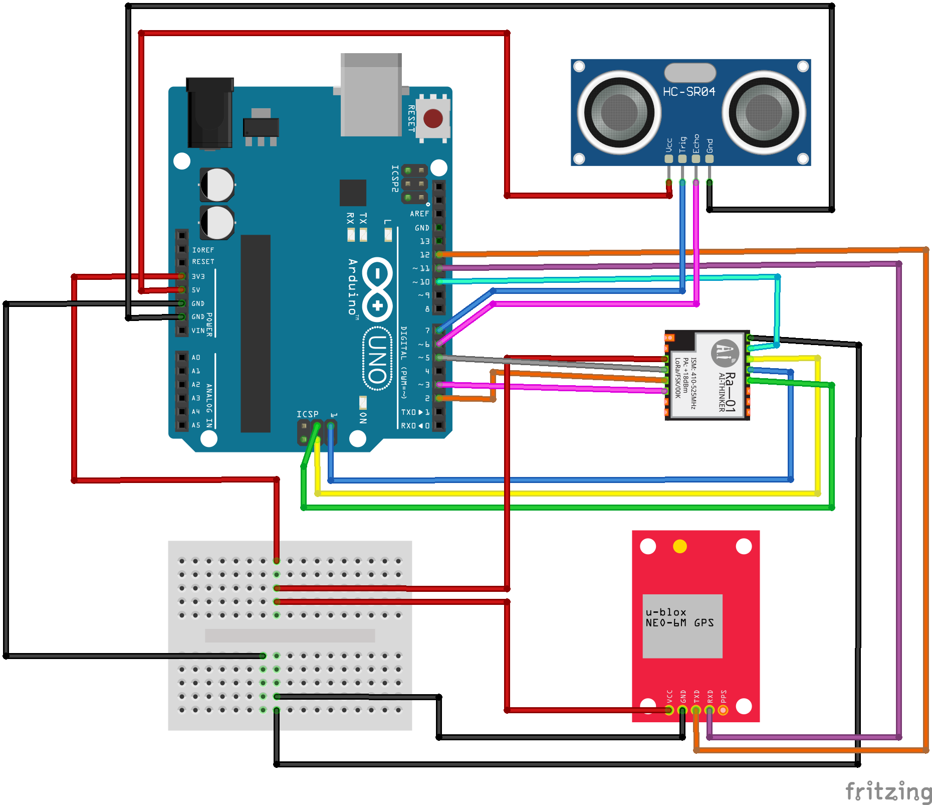

**Figure 5:** Connection diagram for Arduino, SX1276 neo 6M y HC-SR04.

|  |  |
| --- | --- |
| **Arduino** | **SX1276** |
| 3,3 V | 3,3 V |
| GND | GND |
| DI0 | D2 |
| DI1 | D3 |
| MISO | MISO |
| MOSI | MOSI |
| SCK | SCK |
| D10 | NSS |
| D5 | Reset |

**Table 3:** Arduino to SX1276 pin mapping

|  |  |
| --- | --- |
| **Arduino** | **Neo-6M** |
| 3,3 V | 3,3 V |
| GND | GND |
| D11 | RX |
| D12 | TX |

**Table 4:** Arduino to Neo-6M pin mapping

Connection between the arduino UNO and HC- SR04 are de same that stands in table 2. The controllers were programmed using a LoRa Library for arduino written by Matthijs kooijman [2] the library implements a listener method which is responsible to establish a communication session with the IoT server after joining request gets accepted, the distance measured by the sensor can be encoded and transmitted.

4.2. Data collection and transmission

Now that data has being capture and transmitted by measure units, we expect to obtain this data remotely so it is necessary to configure the gateway, the server and the broker.

For the gateway component we found commercial that can gather data transmitted with lora modulation in a defined frequency, the selected reference was LG02 from Dragino, this gateway offers a User Interface UI to set up all transmission parameters among them, Spreading Factor SF, band width BW, Frequency, coding rate and IoT service provider, the parameters selected for our reception channel are the ones show in figure 6. This gateway has 2 communication channels that allow it to operate in full duplex[1].

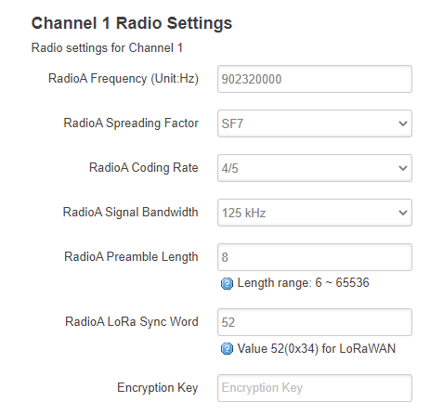

**Figure 6:** Gateway settings for reception channel.

|  |  |
| --- | --- |
| **Channel 1** | **Reception** |
| Frequency | 902320000 |
| Spreading Factor | 7 |
| Coding Rate | 4/5 |
| signal Bandwidth | 125 khz |
| Preamble Length | 8 |
| Lora Sync Word | 52 |

**Table 5:** parameter for reception channel

|  |  |
| --- | --- |
| **Channel 1** | **Transmission** |
| Frequency | 923300000 |
| Spreading Factor | 7 |
| Coding Rate | 4/5 |
| signal Bandwidth | 125 khz |
| Preamble Length | 8 |
| Lora Sync Word | 60 |

**Table 6**: parameter for transmission channel

After completing gateway configuration it was started in listening mode, and connected to the network using the Ethernet interface.

For the IoT server we decide to use the things Network[2] TTN because it supports LoRaWAN protocol e.g. activation by personalization ABP and Over the Air Activation OTAA as authentication methods, TTN simplifies the implementation of decoding and validation rules for the information being reported by nodes consequently information can be filtered before doing any pos-processing operations.

The very first step to use the server is to register the gateway via TTN the administration console, there some information such as identification code, frequency plan and the type of antenna the gateway has attached is required, after the gateway is configured it is show in the console see figure 7. Notice that when the Server established connection with the gateway the status is set to connected.

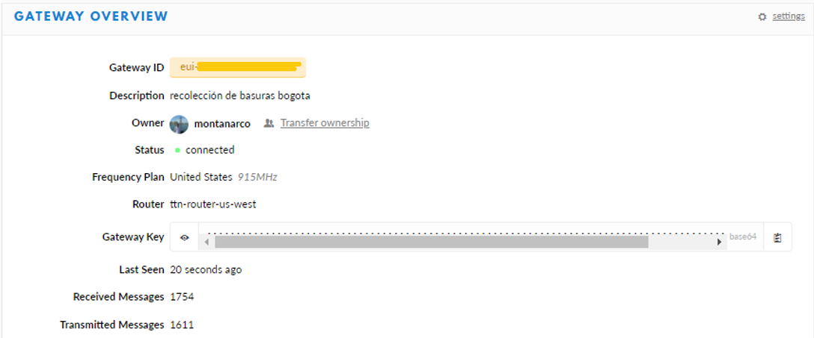

**Figure 7**: Gateway registry on TTN.

Other thing that was configured in the server was an application, that has 2 purposes first is to associate all the measure nodes that will be part of the network, second to define general rules and procedures that will be applied to the information reported by the nodes associated to the application, so that information can be manage in a generalized way e.g. decode functions, and integrations.

In our case the measures taken in the remote devices is encoded in an array of 8 bytes length, bytes 0 to 2 were used to encode latitude, bytes 3 to 5 were used to encode longitude and bytes 6 and 7 were reserved for fill level so we use a decode function that transforms this 64 base byte array into a JSON format which is more compressible for users.

then the integrations pahse defines how to process data after it is received and validated in the server, we decide to use a MQTT broker because the server implements a Mosquito[3] instance and create a topic with the name of the application configured, this way whenever new data coming from measure units reaches the server and it is evaluated right according to the validate and decode functions, the readable payload is publish in the topic created for the application in the broker. As soon as the IoT server was configured, it was started along with the gateway so both remain up and running.

Following step was to extract data from the broker thus an MQTT client was implemented and ran in the backend server, we used a java implementation offered by TTN the repository is open and it is available in public repository[4] the code has a listener that continuously demands for information to the broker, when new information is obtained we use a function that process these data, the function search the id code of the dumpster that sends the information, then that data gets stored in a postgres data base.

4.3. Transmission results

After configurations an running of the network we start transmission test figure 9 show the log running on the gateway it show encoded messages being reported by nodes and captured and retransmitted by the gateway.

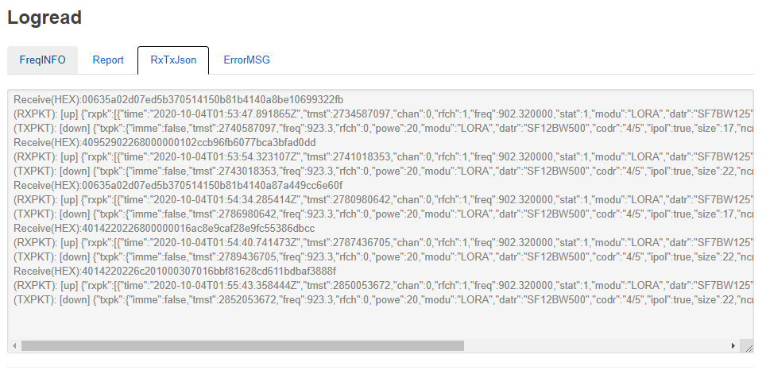

**Figure 9**: log of messages passing through the gateway.

Figure 10 is a screenshot of the data application interface that show messages that where correctly decoded and validated according to the rules defined for the application. Notice that messages from the 3 configured end nodes are being received in the server.

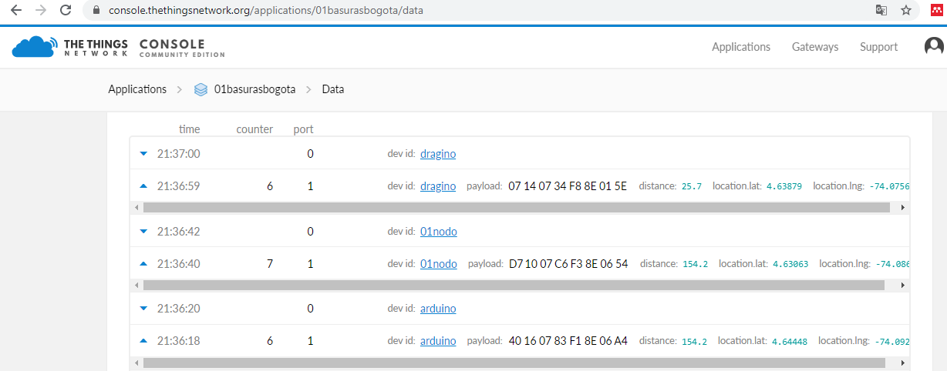

**Figure 10**: messages received and validated in the IoT server.

Figure 11 is the log of the MQTT client running on the back end side; it takes the new messages form the application topic in the broker. At this point information has already being decoded so the payload can be read we can recognize 2 elements Distance and location (lat-lon), then the application matches the reported information to their correspondent dumpster based on code used to index it on the database.

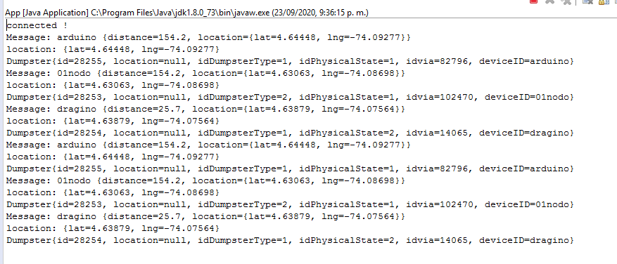

**Figure 11**: data collected by the MQTT client subscribed to the TTN application topic.

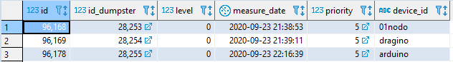

**Figure 12**: data storage in database after being retrieved by MQTT client.

Figure 12 is the result of a query on the data schema that shows the last measured reported by the nodes connected to the network.

The data remains available so when any application needs it, it can be directly query to the database. A simple web application was implements to visualize the data collected by measure units, see figure 13.

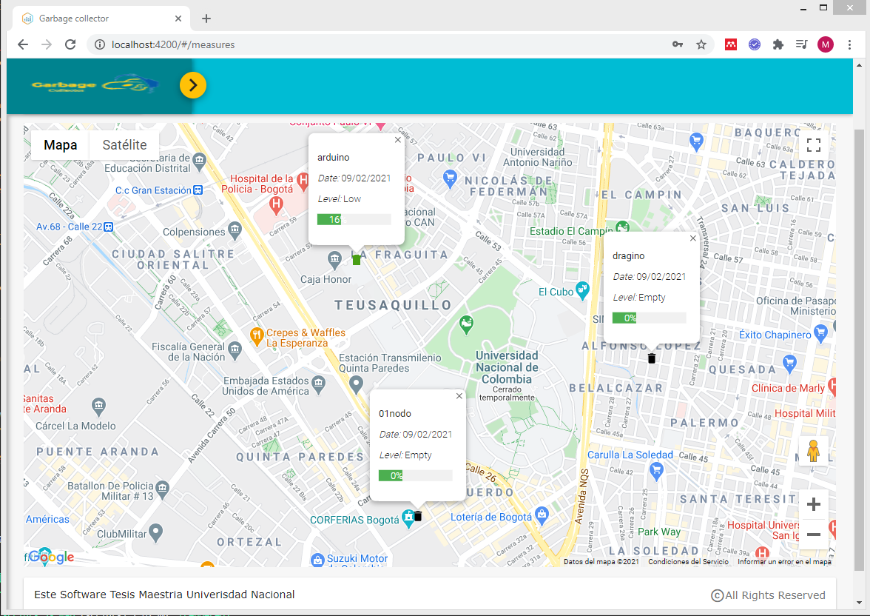

**Figure 13**: web application displaying data reported by measure units.

*The first result to highlight was that information flows along LoRa network delivering data from measurement unit to the backend database as expected*.

We carried on the research executing a couple of tests to verify the real range of distance reached by transmission modules we selected. So started the gateway and place it in a fixed location, then devices were configured to send a message each minute, these data was stored in the database then data was represented in a map and longest reached distance was measured.

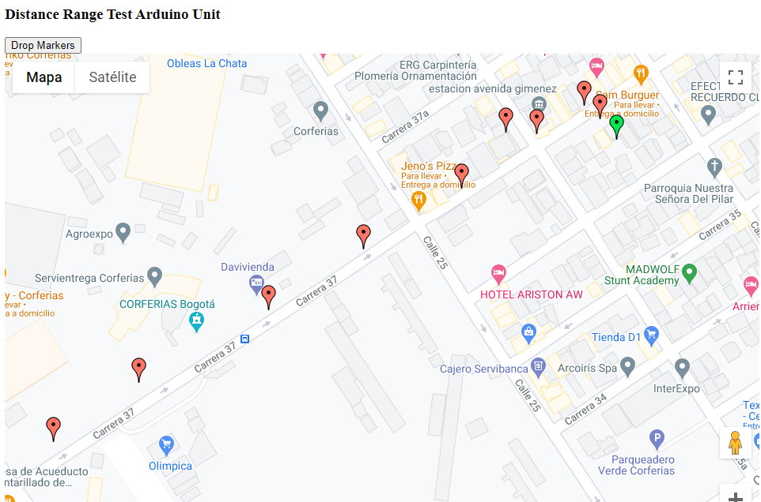

**Figure 14**: Results of Arduino unit sending data.

First test results are showed in figure 14, the green marker represents the gateway location, red markers indicate location retrieved by the GPS in the measure unit, reported in the server and stored in the database. We select green marker and the furthest red market locations, after that we use Google maps to approximate distance, the longest distance was about 488 meters, see figure 15.

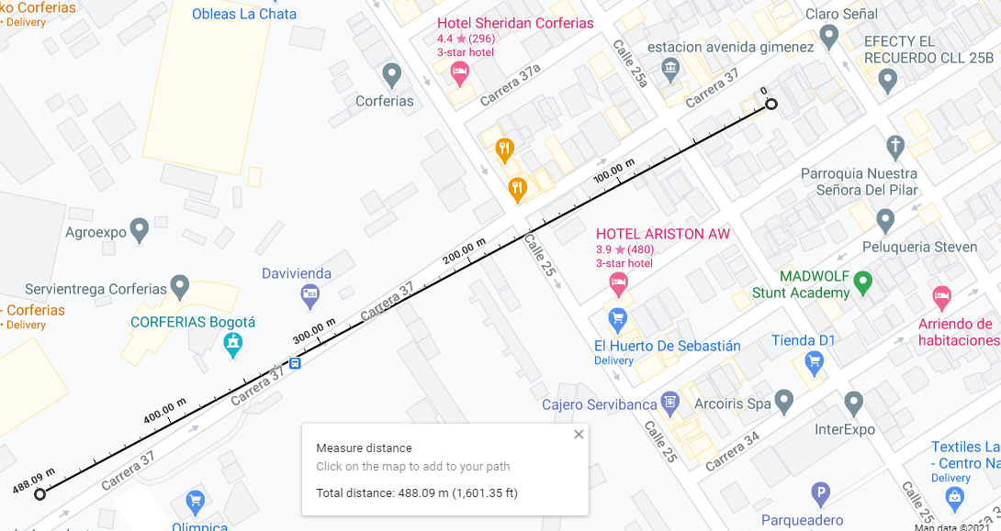

**Figure 15**: maximum range reached with Arduino unit.

This test lead us to realize that signal did not reached the gateway when there was an obstacle e.g. a wall that interrupts direct line of sight, so we conclude that to have an effective transmission there must be a direct line of sight between both devices. Hence, for the second test, we decide to find a high-level location to place the gateway then we start walking away from the gateway in a low-density building area so the direct line of sight was easier to achieve.

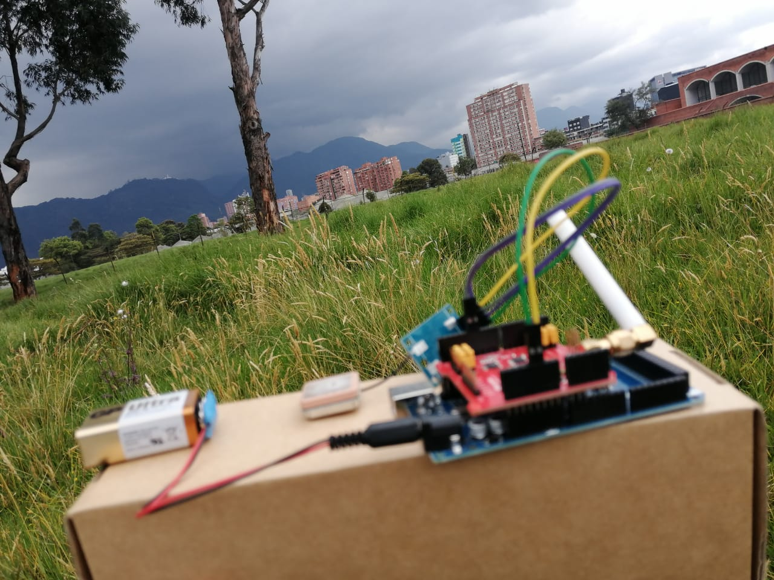

**Figure 16**: Dragino Unit executing data transmission test.

Figure 16 shows Dragino device used to execute the test; gateway was located in the 13th floor of the building show in the upper right hand side of the picture. These test showed longer distances than the first one 1.39 km to be precise, see figure 18.

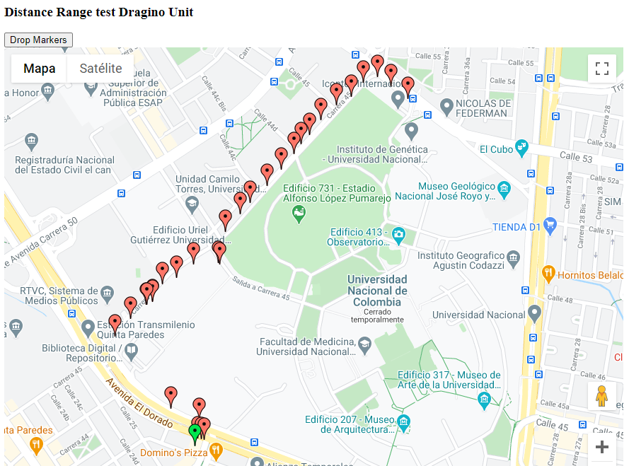

**Figure 17**: Results of Dragino unit sending data.

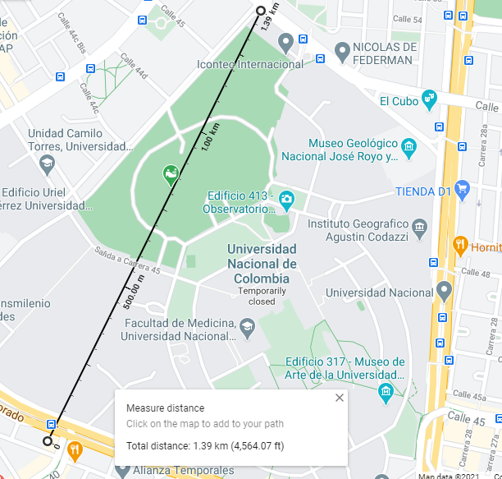

**Figure 18**: measurement of maximum range reached with Dragino unit.

A regard to consider is that according to (Sagir, Kaya, Sisman, Baltaci, & Unal, 2019) range coverage can be extended in dense urban areas augmenting the SF, this happens because high SF extends airtime signal giving more chances to the receptor to receive the message, this configuration reduces the data rate.

4.4. Data Simulation

As we only provide with 3 real measure units it is impossible to generated significant plans and routes for collecting RSU other than visiting the locations of our 3 measure units. So for these reason it was required to simulate a bigger amount of units reporting fulfillment levels and evaluate route calculation in more complex conditions.

To simulate container locations, we defined a set of rules:

1. a container should be located on a street were a truck can reach it
2. containers are located always in pairs 1 for general purpose waste and 1 for recyclable material,
3. Each pair of container should be separated by at least one street length distance, these is to say 100 meters.

Third rule was thought to find an even distribution of containers avoiding many containers to be crowded in the same area. To implement first rule it was necessary to have geographical information of street configuration in the study region, therefore we download geographical data form “Unidad Administrativa Especial de Catastro Distrital Bogota” IDECA. The first set of geographical data contains the street axis lines that shapes the ways mesh of Bogota, and the second that contains the membership of blocks and neighborhood to Bogota districts.

Downloaded information was treated and organized; simulation was divided in 2 phases: the first one was to put representations of empty containers in the street were a truck could reach them and finding an even distribution along the study area. To do so we used the street locations and we find a point contained in the street coordinate, the generated containers where represented in a map as show in figure 19.

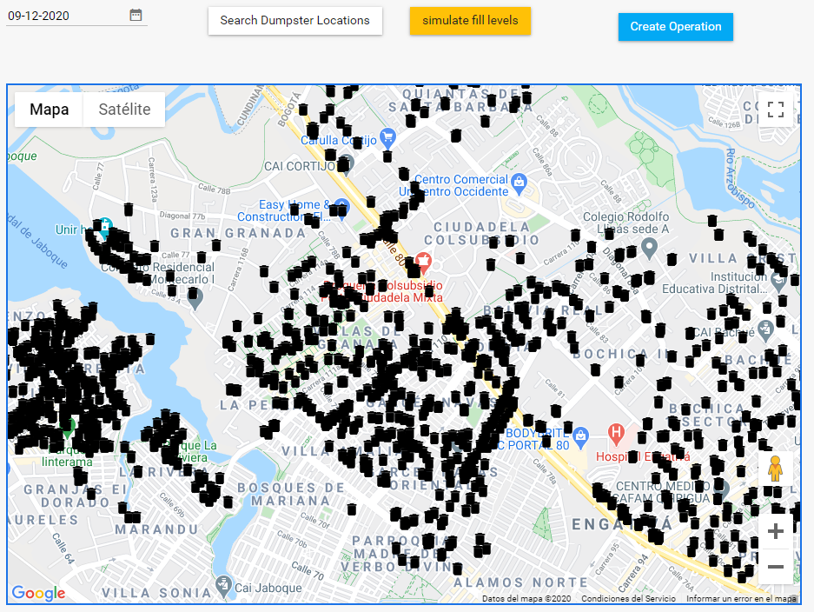

**Figure 19**: phase one container location simulation.

The second phase was to update the level of containers using random numbers between 0 and 100 representing the percentage of fulfilment, these numbers have the same mean and standard deviation found in a dataset of waste collecting routes from Austin Texas downloaded from Kaggle[5], the colour of each container was updated according to convention show in table 7, The result is show in figure 20.

|  |  |  |
| --- | --- | --- |
| **level** | **Priority** | **Color** |
| Less than 10% | empty | black |
| Between 11% and 30% | low | green |
| Between 31% and 55% | medium | yellow |
| Between 56% and 80% | high | purple |
| Greater than 81% | full | red |

**Table 7**: colour code for container priority representation

This filling percentages where defined based on the test executed by (Meesala et al, 2018) which where validated using a measure device that integrates an ultrasonic sensor, and consider the directive angle of the sensor signal.

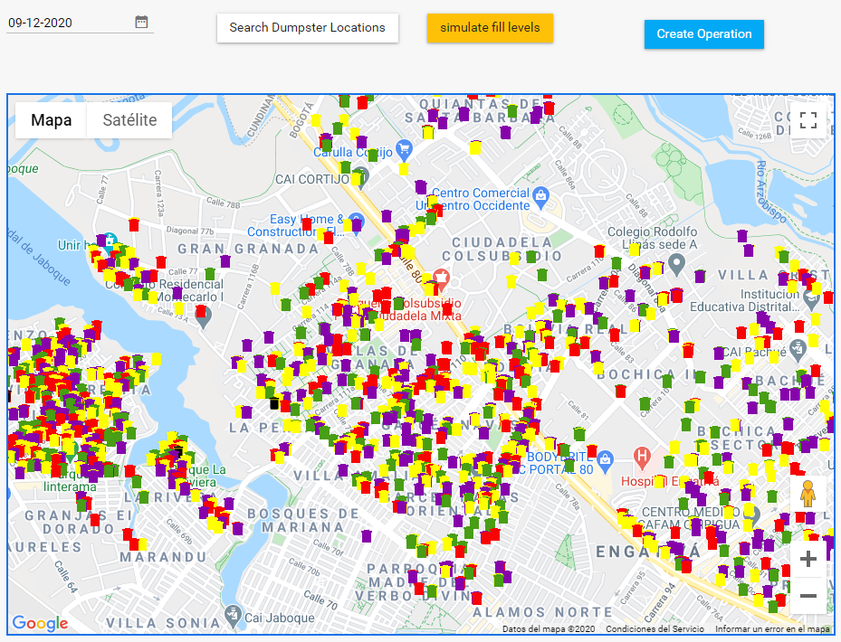**Figure 20**: phase two container filling level simulation.

We consider some facts so that the operation would be more efficient for instance if the truck must go across a street to collect a the content of a high level container, it must collect other containers in the same street, because when it collects only the container that reports the high level on the next days it should return to the same street to collect other containers increasing the travel distance.

It is required to reduce streets distance between containers as sometimes containers may seem spatially closed, but the streets connecting them are not, so in many cases we must collect first containers that are spatially further but whose travel distance length is less.

Having these in to account it result easier to prioritize the streets where containers are located, rather than containers, then we establish the street priority based on the rules defined in table 8.

|  |  |  |
| --- | --- | --- |
| Street Priority | dumpster level reported | Description |
| 1 | full > 0 | there is at least a full container, or the container has not being collected in more than 3 days |
| 2 | high > 0 | there is at least a high level container, or the container has not being collected in more than 2 days |
| 3 | Medium > 0 | there are only containers with medium and low level |
| 4 | low > 0 | there are only containers with low level |

**Table 8**: rules to define street priority

With clear information of containers that has to be collected and streets prioritized we are almost ready to start planning the collection operation, but route calculation can be computational expensive and time consuming, so thinking over that for routing vehicles we will use an heuristic search base on tree spanning, and as we know the approximate volume of MSW that should be collected and the capacity of trucks in the fleet, we can estimate the number of truck required for the operation, even more, knowing the location of containers we can group the ones that are geographically close in such a way that those containers can be served by the same truck.

K-means Clustering has being applied in MSW collection planning, as one of the important prepossessing task before routing in (Vu & Kaddoum, 2017) they worked with data of Philadelphia. Pennsylvania, USA. Using geographical coordinates; latitude, longitude as grouping feature, they apply Elbow method as convergence strategy and a logistic regression to forecast the dumpsters that will probably be full so they must be included in the operation. Taking some elements of this research we decide to use K-mean as clustering method, it is fully explained in (Nazeer & Sebastian, 2009). But the fundamentals steps behind this method are:

1. To define a feature reference and a number of groups.
2. Initial groups centroids are defined randomly, then elements are assigned equitably to the groups, one element is assigned to a group whose centroid is closer with respect to the value of the element itself.
3. the group centroids are recalculated extracting the means of the elements assigned to that group, and the elements are relocated in new groups according to the new group centres
4. The operation is iterative and it repeats until there is no reduction in global distances.

Global distances is calculated as the sum of the distances of each elements to the centroid of the group where it was assigned, by reducing distances in each group global distance is also reduced.

For the clustering we implement a function that sums the volume of MSW located in the streets that have priority 1 or 2, using this volume we estimate K as the number of trucks required for the operation, that number matches the number of groups. So after the grouping, each truck could be assigned exactly to one group, thus we include a constraint to avoid that a groups of streets accumulates more volume than the one the truck could carries. Then we extract the centroid of those streets in terms of Latitude, Longitude and we use these values as reference features. The result of streets clustering is show in figure 21.

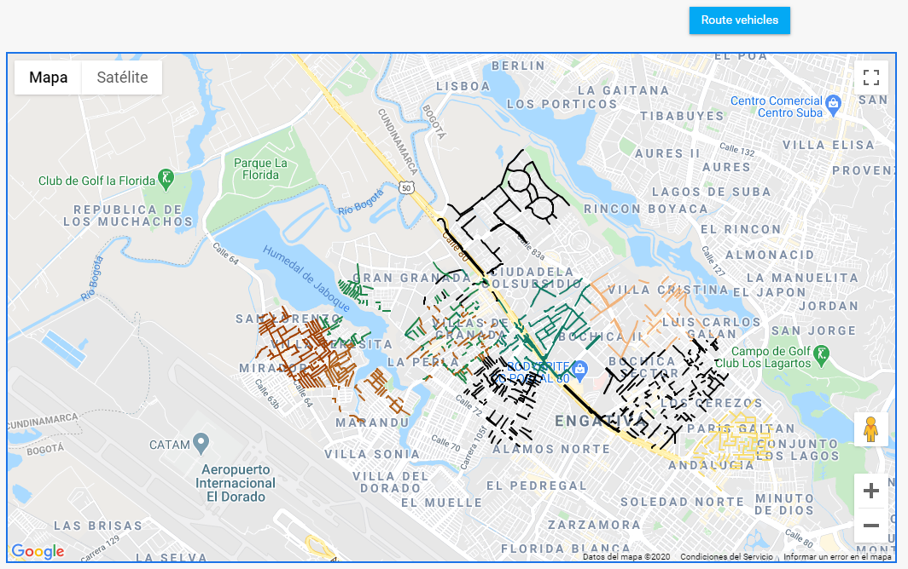

Figure 21: prioritized streets using K=9.

4.5. Route Calculation and Delivery

Once streets were prioritized and grouped the next step was to find a collection sequence that reduces travel distance in each group, taking advantage of available open services we decide to use one applied to route vehicles ORS[6], the service uses a routing strategy called tree spanning which consist in finding the way of connecting nodes in different locations to a central node, an economic way to do so is connecting all nodes in one direction by a single line, in this way all nodes connected in the same direction, can use the same path to arrive to the central node, the routing cost for 2 vertices is given as the sum of the cost of the edges in the unique tree path between them. (Gouveia & Martins, 1999) the strategy was originally proposed for communication routing, nonetheless considering the streets distance or time as a factor of the route cost, it can be applied to vehicle routing. (Wu et al., 2000) The service performs some modifications to the initial solution trying to reduce distances applying operators, some of them are, relocation, interchange, inversion and alteration the solution strategy has being described in detail by (Zhou, et al. 2018) the service developers have publish another video explaining service solution strategy, functioning and use, this video can be accessed in (Coupey, J. 2018).

As ORS service is offered through and API getting a key to use it was compulsory, the service we needed was optimization, these requires to specify the places to visit and the truck features in a structure manner in JSON format which is documented in an open repository[7]

k-means grouping is a significant progress in 2 ways: first doing the assignation so we know in advance which truck will serve a group of containers and second the centroid of each group is handy as start location for each truck, so when we executed a routing task with the service we attach exactly one truck, then we transform each container location that belongs to the group into a job using the format the API expects. As a response the service return another JSON containing a lists of trucks with an array of container locations with high priority that the truck must visit, with an specific order that reduces the travel distance, a request example is shown in figure 22, then solution is stored in the database avoiding reprocessing every time an application demands routes, so the routes information is available as soon as external applications require it saving time, but also considering the service limitation of use per day.

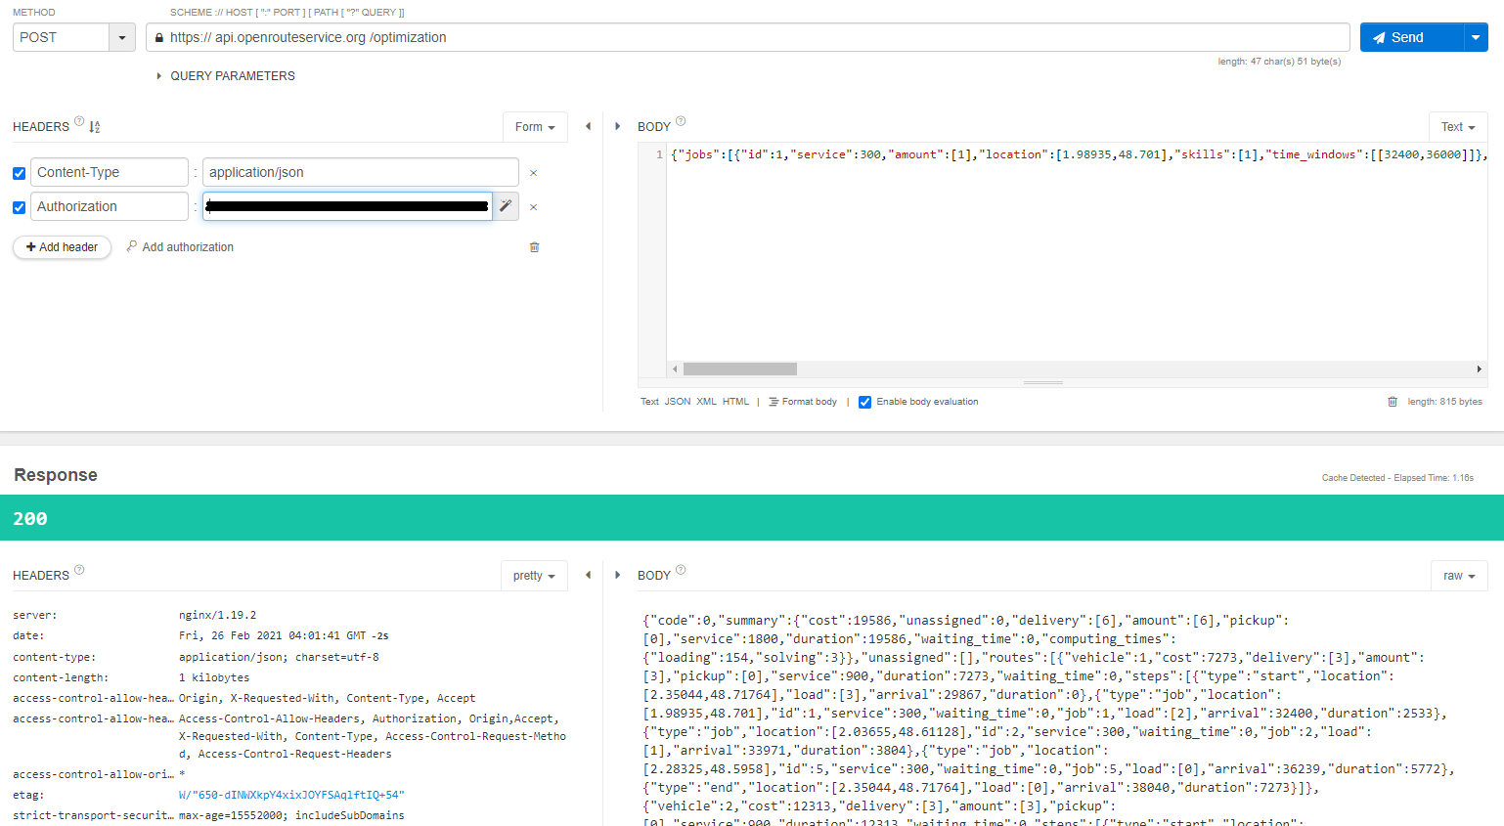

Figure 22: ORS API route request, optimization service

Up to this point we have the routes in geographical coordinates, now we need and effective way to display information to users in an easy to read and understand format. Considering that it is likely that persons who are going to use this information are truck drivers while searching dumpsters, it would be comfortable to visualize information in a portable device with internet connection, for this reason we consider a mobile application could fit these requirements.

A mobile application was coded in Flutter a recent Google framework for mobile application development it has an easy integration to Google services, such as Google Maps, we use a REST architecture for the application simply exposing services to handle request made by client applications, this is a simple way to transfer information in JSON format: some of the services exposed were authentication, generated routes in a specific date.

The application demands for user authentication, this user has a role whit permissions to see all generated routes. The list of routes is query via get verb using the date as parameter, the response is a list of routes is display in a component called list view see figure 23.

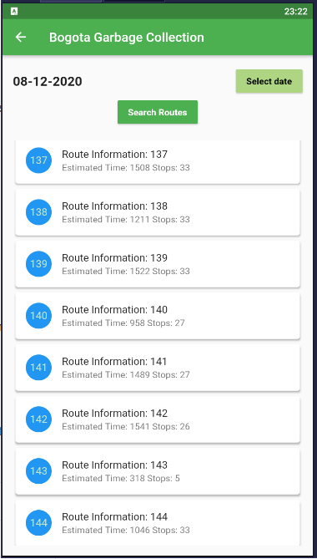

Figure 23: list of routes planned for 08 December 2020

By tapping in one element of the list, the plication will display the locations of containers that must be served for the current route see figure 24

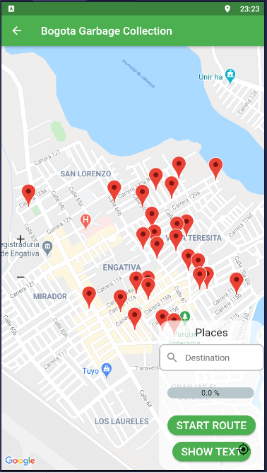

Figure 24: initial view of container when a route is selected

When start route button is pressed the application will consume Google Directions API to find the fastest way to arrive from the driver current location to the first container in the route using real-time traffic information, when the first container is reached and served the next container button is enabled to find the path from last visited location to the next container in the route, this operation is repeated for all container in the route, a progress bar indicates collection progress it is updated when a new container is reached.

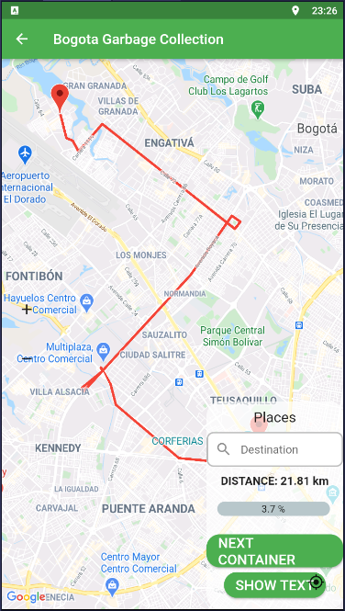

Figure 24 route from driver location to the first container

1. Discussion

To evaluate results we would prefer to analyse them separated by layers. In regard to the data collection process denominated the physical layer. The measurement units extract precise fulfilment levels and communicate them in efficiently to the server, MQTT broker acts as bridge to connect IoT server and Back-End services then data can be stored in a data base where applications can easily access it. In that sense we consider that even though there are some elements that can be enhanced, system physical part is doing the work.

The logical part of the system is an approach of how is possible to profit and handle collected data, possibly there are more precise and efficient ways to treat this data; clustering containers needs to consider terrain characteristics, implementing other routing strategies or using private routing services should be validated and compared to the obtained results to select the most suitable to plan collecting operation.

Although simulated data does not match the actual waste generation in Bogotá and it was used for academic purposes only, therefore this study does not compare the obtained routes to the routes are currently being applied to collect waste in Bogotá city, simulated data is valuable as it could be used as benchmark to evaluate routing algorithms performance.

There are still elements that can significantly improve in the system, here we point some of them, using LoRa as transmission technology needs some considerations: since LoRa uses a star topology gateway centred, it is required to find an efficient gateway distribution to maximize coverage region reducing number of gateways, a 50% of coverage overlapping is highly recommended so that each measure node is to be served by at least by 2 gateways, this generates a fail tolerance in case any gateway is temporally out of service, another gateway in the network might serve as back up for the nodes allowing them to continue delivering measures an keeping them communicated with the server.

Gateways should be placed in altitude above building average height, trying to generate a direct line of sight from it to measurement units so messages are deliver and received in the gateway. notwithstanding tuning parameters as Spreading Factor might upgrade signal power so when signal gets obstructed by obstacles as wall the gateway can still receive the signal, in areas where many nodes are deployed is convenient review node distribution and configuration as suggested by (Premsankar, Ghaddar, Slabicki, & Francesco, 2020) .

When grouping containers other factors need to be reviewed not only geographical proximity, for instance hydric resources as wetlands and rivers. In this work, we realized that clustering aggregates containers that were relatively close, but some of them were separated by a river, so aggregating those in the same group imply to circle the river until the next bridge, which increases travel distance this affects negatively the route efficiency when evaluated based on travel distance. To solve the problem a clustering strategy with spatial boundaries should be implemented in such a way that elements would be assigned to groups within the hydric boundaries and not overstep those limits.

Before implementing the proposed collection strategy a relocation of containers is required, it is necessary to conciliate a place where containers will be reached easily for citizens and recycling enterprises staff, but situated in easy access ways minimizing detours, or narrow ways were truck transit is difficult and could slow down the operation.

Measurement units need to be improved on two facts: first they need to manage energy efficiently, for that it is required to adapt low consumption switches that turn on the devices exclusively when they will extract measures possibly 2 or 3 times a day, the other time they need to remain in sleep mode. Photovoltaic cells might be a good energy alternative. Second, an external case need to be designed to protect circuits from weather conditions and manipulation damage.

Measurement units can perform very good if dispense with GPS sensor, it is not decisive as container locations can be indexed to the data schema when units are installed and identified by a unique id code, this reduces nodes cost in 33% approximately but also reduces energy consumption.

To increase profits on collected material routes should be separated; there must be at least two types of routes: one to collect general disposable waste and other for recyclable material. Last one is to be classified and manage properly avoiding it to get contaminated and come to an end in landfills where it becomes a source of contamination and damage for the environment.

The mobile application does not show exact alignment between the streets delivered by the maps provider and lines used to show routes, this happens because data used for simulation and routing uses a different geographical system reference than the maps provider. While data used for simulation and routing was coded using Magna Sirgas, official Bogota geographical reference system, maps provider uses the World geodesic system 84 WGS84, this causes that visually the paths shows a slight deviation, it is necessary to find a map provider that uses a reference system similar to Magna Sirgas.

1. Conclusions

MSW has being increasing in last year’s affecting humans health, life style and environments, the municipalities made a great effort to treat waste in a responsible an sustainable way, to target this situation an efficient sensing system was proposed, that let municipalities to plan and take data driven decisions. A prototype was implemented, using LoRa as transmission technology data flow was managed along all network components until data stored it in a GIS database, collected data was processed to generate collection routes that priories the gathering of containers showing high levels, increasing collected volume and reducing travel times, planned routes were displayed in a mobile application to guide truck drivers throw the path to complete route as support for the operation.

This research shows how updated data is an important asset that cities can take advantage of to better plan typical operations as MSW collection, the development of this sensing system demonstrates technical viability to implement this collection schemas in real environment, showing that logistic process of MSW collection can by enhanced with communication technologies to reduce container saturation and overflow.

As future work a comparison of proposed routes against the routes that are being used to validate if the proposed system has a valuable impact in the collecting operation, if so the model should be extended and generalized to as an open framework for cities to manage their MSW in an efficient and sustainable way.

ACKNOWLEDGMENTS

REFERENCES

[+]Kaza, S., Yao, L. C., Bhada-Tata, P., & Van Woerden, F. (2021). What a Waste 2.0 : A Global Snapshot of Solid Waste Management to 2050. World Bank Group.

[1] Nazeer, K. A & Sebastian, M.. (2009). Improving the Accuracy and Efficiency of the k-means Clustering Algorithm. Lecture Notes in Engineering and Computer Science. 2176.

[2] Meesala, Sirisha & Manoj Kumar, Nallapaneni & Parimala, Sugathi & Jyothi, N. Arun. (2018). Monitoring the smart garbage bin filling status: An IoT application towards waste management. International Journal of Civil Engineering and Technology. 9. 373-381.

Heidelberg University. (1997, February 19). TSPLIB. TSPLIB. <http://elib.zib.de/pub/mp-testdata/tsp/tsplib/tsplib.html>

Abdulkader, M. M. S., Gajpal, Y., & Elmekkawy, T. Y. (2015). Hybridized ant colony algorithm for the Multi Compartment Vehicle Routing Problem. *Applied Soft Computing Journal*, *37*, 196–203. https://doi.org/10.1016/j.asoc.2015.08.020

Amal, L., Son, L. H., & Chabchoub, H. (2018). SGA: spatial GIS-based genetic algorithm for route optimization of municipal solid waste collection. *Environmental Science and Pollution Research*, *25*(27), 27569–27582. https://doi.org/10.1007/s11356-018-2826-0

Babaee Tirkolaee, E., Abbasian, P., Soltani, M., & Ghaffarian, S. A. (2019). Developing an applied algorithm for multi-trip vehicle routing problem with time windows in urban waste collection: A case study. *Waste Management and Research*, *37*(1_suppl), 4–13. https://doi.org/10.1177/0734242X18807001

Bingol, E., Kuzlu, M., & Pipattanasompom, M. (2019). A LoRa-based Smart Streetlighting System for Smart Cities. *7th International Istanbul Smart Grids and Cities Congress and Fair, ICSG 2019 - Proceedings*, 66–70. https://doi.org/10.1109/SGCF.2019.8782413

Bustos Coral, D., Oliveira Santos, M., Toledo, C., & Fernando Niño, L. (2018). Clustering-Based Search in a Memetic Algorithm for the Vehicle Routing Problem with Time Windows. *2018 IEEE Congress on Evolutionary Computation, CEC 2018 - Proceedings*, 8. https://doi.org/10.1109/CEC.2018.8477710

Campbell, A. M., & Wilson, J. H. (2014). Forty years of periodic vehicle routing. *Networks*, *63*(1), 2–15. https://doi.org/10.1002/net.21527

Cerchecci, M., Luti, F., Mecocci, A., Parrino, S., Peruzzi, G., & Pozzebon, A. (2018). A Low Power IoT Sensor Node Architecture for Waste Management Within Smart Cities Context. *Sensors*, *18*(4), 1282. https://doi.org/10.3390/s18041282

Chaudhari, S. S., & Bhole, V. Y. (2018). Solid Waste Collection as a Service using IoT-Solution for Smart Cities. *2018 International Conference on Smart City and Emerging Technology, ICSCET 2018*, 1–5. https://doi.org/10.1109/ICSCET.2018.8537326

Chaudhary, S., Nidhi, C., & Rawal, N. R. (2019). Gis-based model for optimal collection and transportation system for solid waste in allahabad city. *Advances in Intelligent Systems and Computing*, *814*, 45–65. https://doi.org/10.1007/978-981-13-1501-5_5

De Castro Tomé, M., Nardelli, P. H. J., & Alves, H. (2019). Long-Range Low-Power Wireless Networks and Sampling Strategies in Electricity Metering. *IEEE Transactions on Industrial Electronics*, *66*(2), 1629–1637. https://doi.org/10.1109/TIE.2018.2816006

Faulin, J., Juan, A., Lera, F., & Grasman, S. (2011). Solving the capacitated vehicle routing problem with environmental criteria based on real estimations in road transportation: A case study. *Procedia - Social and Behavioral Sciences*, *20*, 323–334. https://doi.org/10.1016/j.sbspro.2011.08.038

Fujdiak, R., Masek, P., Mlynek, P., Misurec, J., & Olshannikova, E. (2016). Using genetic algorithm for advanced municipal waste collection in Smart City. *2016 10th International Symposium on Communication Systems, Networks and Digital Signal Processing, CSNDSP 2016*. https://doi.org/10.1109/CSNDSP.2016.7574016

Gilardino, A., Rojas, J., Mattos, H., Larrea-Gallegos, G., & Vázquez-Rowe, I. (2017). Combining operational research and Life Cycle Assessment to optimize municipal solid waste collection in a district in Lima (Peru). *Journal of Cleaner Production*, *156*, 589–603. https://doi.org/10.1016/j.jclepro.2017.04.005

Gouveia, L., & Martins, P. (1999). The Capacitated Minimal Spanning Tree Problem: An experiment with a hop-indexed model. *Annals of Operations Research*, *86*(0), 271–294. https://doi.org/10.1023/a:1018911003529

Jwad, Z. A., & Hasson, S. T. (2018). An Optimization Approach for Waste Collection Routes Based on GIS in Hillah-Iraq. *ICOASE 2018 - International Conference on Advanced Science and Engineering*, 60–63. https://doi.org/10.1109/ICOASE.2018.8548889

Kang, K. D., Kang, H., Ilankoon, I. M. S. K., & Chong, C. Y. (2020). Electronic waste collection systems using Internet of Things (IoT): Household electronic waste management in Malaysia. *Journal of Cleaner Production*, *252*. https://doi.org/10.1016/j.jclepro.2019.119801

Karthikeyan, S., Rani, G. S., Sridevi, M., & Bhuvaneswari, P. T. V. (2018). IoT enabled waste management system using ZigBee network. *RTEICT 2017 - 2nd IEEE International Conference on Recent Trends in Electronics, Information and Communication Technology, Proceedings*, *2018*-*Janua*, 2182–2187. https://doi.org/10.1109/RTEICT.2017.8256987

Kuo, R. J., & Zulvia, F. E. (2017). Hybrid genetic ant colony optimization algorithm for capacitated vehicle routing problem with fuzzy demand - A case study on garbage collection system. *2017 4th International Conference on Industrial Engineering and Applications, ICIEA 2017*, 244–248. https://doi.org/10.1109/IEA.2017.7939215

Li, Q., Liu, Z., & Xiao, J. (2018). A Data Collection Collar for Vital Signs of Cows on the Grassland Based on LoRa. *Proceedings - 2018 IEEE 15th International Conference on e-Business Engineering, ICEBE 2018*, 213–217. https://doi.org/10.1109/ICEBE.2018.00041

Lozano, Á., Caridad, J., De Paz, J. F., González, G. V., & Bajo, J. (2018). Smart waste collection system with low consumption LoRaWAN nodes and route optimization. *Sensors (Switzerland)*, *18*(5). https://doi.org/10.3390/s18051465

Medvedev, A., Fedchenkov, P., Zaslavsky, A., Anagnostopoulos, T., & Khoruzhnikov, S. (2015). Waste management as an IoT-enabled service in smart cities. *Lecture Notes in Computer Science (Including Subseries Lecture Notes in Artificial Intelligence and Lecture Notes in Bioinformatics)*, *9247*, 104–115. https://doi.org/10.1007/978-3-319-23126-6_10

Papalitsas, C., Karakostas, P., Andronikos, T., Sioutas, S., & Giannakis, K. (2018). Combinatorial GVNS (General Variable Neighborhood Search) Optimization for Dynamic Garbage Collection. *Algorithms*, *11*(4), 38. https://doi.org/10.3390/a11040038

Pardini, K., Rodrigues, J. J. P. C., Diallo, O., Das, A. K., de Albuquerque, V. H. C., & Kozlov, S. A. (2020). A Smart Waste Management Solution Geared towards Citizens. *Sensors*, *20*(8), 2380. https://doi.org/10.3390/s20082380

Premsankar, G., Ghaddar, B., Slabicki, M., & Francesco, M. Di. (2020). Optimal Configuration of LoRa Networks in Smart Cities. *IEEE Transactions on Industrial Informatics*, *16*(12), 7243–7254. https://doi.org/10.1109/TII.2020.2967123

Sadowski, S., & Spachos, P. (2020). Wireless technologies for smart agricultural monitoring using internet of things devices with energy harvesting capabilities. *Computers and Electronics in Agriculture*, *172*, 105338. https://doi.org/10.1016/j.compag.2020.105338

Sagir, S., Kaya, I., Sisman, C., Baltaci, Y., & Unal, S. (2019). Evaluation of Low-Power Long Distance Radio Communication in Urban Areas: LoRa and Impact of Spreading Factor. *Proceedings - 2019 7th International Conference on Digital Information Processing and Communications, ICDIPC 2019*, 68–71. https://doi.org/10.1109/ICDIPC.2019.8723666

Vu, D. D., & Kaddoum, G. (2017). A waste city management system for smart cities applications. *Proceedings - 2017 Advances in Wireless and Optical Communications, RTUWO 2017*, *2017*-*January*, 225–229. https://doi.org/10.1109/RTUWO.2017.8228538

Wu, B. Y., Lancia, G., Bafna, V., Chao, K. M., Ravi, R., & Tang, C. Y. (2000). A polynomial-time approximation scheme for minimum routing cost spanning trees. *SIAM Journal on Computing*, *29*(3), 761–778. https://doi.org/10.1137/S009753979732253X

Yusof, N. M., Zulkifli, M. F., Mohd Yusof, N. Y. A., & Azman, A. A. (2018). Smart waste bin with real-time monitoring system. *International Journal of Engineering and Technology(UAE)*, *7*(2.29 Special Issue 29), 725–729. https://doi.org/10.14419/ijet.v7i2.29.14006

Zguira, Y., Rivano, H., & Meddeb, A. (2018). Internet of Bikes: A DTN Protocol with Data Aggregation for Urban Data Collection. *Sensors*, *18*(9), 2819. https://doi.org/10.3390/s18092819

Zhao, W., Lin, S., Han, J., Xu, R., & Hou, L. (2018). Design and Implementation of Smart Irrigation System Based on LoRa. *2017 IEEE Globecom Workshops, GC Wkshps 2017 - Proceedings*, *2018*-*January*, 1–6. https://doi.org/10.1109/GLOCOMW.2017.8269115

1. Full duplex is a communication mode that allows to emit and receive messages simultaneously.
2. <https://www.thethingsnetwork.org/>
3. An open source lightweight MQTT broker supported by Eclipse foundation
4. https://github.com/TheThingsNetwork/java-app-sdk
5. https://www.kaggle.com/jboysen/austin-waste
6. Open Route Service
7. <https://github.com/VROOM-Project/vroom/blob/master/docs/API.md>